Linux (Invented by Linus torvold)

is secured

is open source

Linusx is available in two interface Command line interface and user interface

CLI-wheere work with command line..  
Every service having a port

Disturbiton of linux - Ubuntu,redhat,centos,fedora

Linux and Unix

Unix is older than linux.

AT&T lab were used for open source

Licensed based (unix)

File format supported

Disk partition

Virus

In Window we use folder but in linux we use directory.

/ root directory

Pwd-present working directory

Ls-list

Touch-make a new file

Mkdir - make a directory

Rmdir - remove the directory (**when the directory is empty**.)

Rm - remove

Man - manual for the command

Rm -r recurssive

Rm-v –vervose ( to explain about the directory were removed)

Rm -d – remove the

-rf - remove all files.

Ls - l

History - code written

Cp - copy

Ctrl + l = page up scorll

Cd.. - for back to parent directoryy

Cd folder nama/-go to child directory

/home/abc → absolute path

-p —> if there was no parent,nmake a parent dire

Abc → relative path

. → current path\

Mv - for moving the file form one place to another.

Whoami-

-sudo

-user root

. reperesnet the present location

***For renaming the file (git mv file name updated name) - GIT***

Absolute path

Relative path

Find command used for find the file which is based on particular parameter,

ls/folder name – to check the file is present at that location.

/ =>home folder

Task to do?

Difference between linux & unix

Find out those files which has been created vefore 5 min?

Find out the files whose size is less than 5mb?

Now a create a file 100mb?

Find out the file & folders which have size of more than 95mb?

Find out the files which as a size of less than 200mb?

Find out the fukes which as starting name with a and t and file should end with .txt?

In current folder create two folders named with regex and learning

In regex data.txt and data1.txt

Data.txt copyfile to learning

Copy all content of regex to learning

Copy folder of regeex to learning

Delete the regex folder completely

Todo

**Q 1 Go to home user create a folder named as a documents than create a file inside a document with the name of data1.txt and data2.txt**

**1 - delete data1.text from /home/user/l**

**2 - from the same location ,delete complete document folder**

**Q 2 Create two folder ipl and virat kohli**

**Virat kohili having a file match.txt**

**Copy match txt to ipl folder**

**Make 150 files in ipl folder (dont use touch)**

**match1.txt ipl2.txt ……………………..ipl150.txt**

**3 delete files from ipl1.txt to ipl150.txt , move match101.txt to match150.txt ipl to virat folder**

**4 virat and inside content in virat kohili to move in ipl folder**

**Q3 using mkdir command you haveto make three folder (desktop/follder/regex)**

SINGLE CHARACTER = ALPLHABHET + NUMERIC

* ZERO

? only 1 character

[ ] range of characters

If the directory dont have any file or folder than its dont show the ls

a* - find all the file named starting forom a

J? - find character minimum atleast with 2 character

[a-d]- file starting from a to d showing all folder and file is showing

Q to find b and third character z b*?[z]

2 atleast 4 character and 2 and last character o? *?[o]?

Staring 2 character a or t and ending third character o-z.

Pattern esi file first charcter C - P or u-y and last character 5 -9?

Links

Relation

Type of links

Hard and soft

Arrange and love

Hard liink

Create a home folder in home directory

* Now move the folder homefolder to user
* /home//user create a file tushar.txt move the file tushar.txt to tushar folder but name should be changed user.txt ..only 1 command()

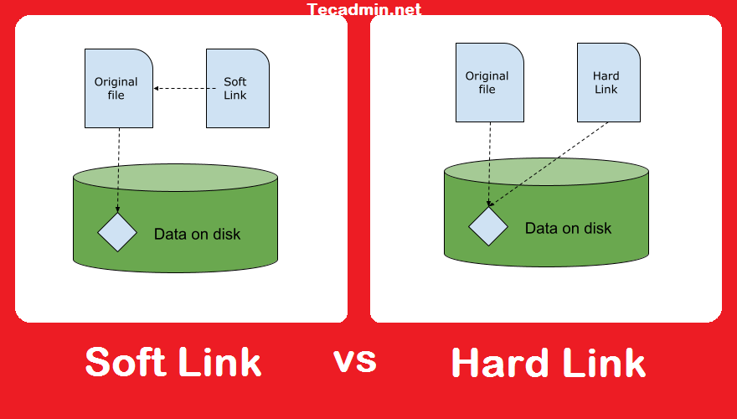

-il - incode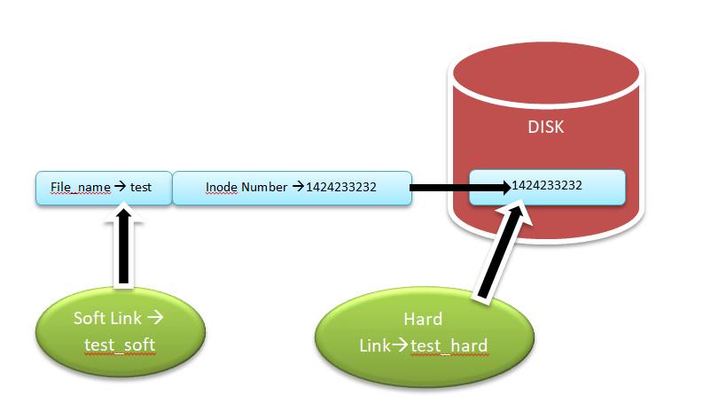

Cat file name - opening a file

If you are using hard link if you deleted afile the past file is always be there.no data will be ermove.

Hardlink is always made in same partition.

If the original file is deletedf softlink dont work

-s making a soft link symbolic link

If we creating a file and dont giveng file extension (reason behind)

[at] or condition

Editors

Notepad

Cli based editor

Commands

Nano,vi,vim

vi/vim - vi editor

Command -> insert a,i,o

Insert → command esc

:w save  
:q quit

O next line

Esc:wq enter save and

A - append starting from initial

I- to just next

O for next line

! forcefully

To copy yy copy

P paste

2yy copy

P paste same for 100 line 100yy to p

For cut

Dd for delta

And p for paste

For delete

Dd - line where cursor is blink

For going for any,line

Than use line number and g like 10g its mean it goes to 10th line GG

UNDO FOR U

**Find commands**

**Find /home/usernamme/ -name data.txt**

**-lh**

**Sudo - run as a root**

**find /home/ghansojha28/test/ -type f -user ghansojha28**

**Exec - j**

**Copy -type f -user ghansojha28 -exec cp {} /home/ghansojha28/backup/ \;**

**Cw**

**Use A find command to get the file more than 100 mb.**

**Create a 100 mb file than find**

**Now get those file less than 100 mb?**

**Find the file just modified before 5 mins ?**

**Find out those files current user id**

**-1 find userid**

**-2 find the search file**

**Make 3 files 2 files have some text and 3 file blanck**

**Create a two file 1 two hardlink 2 1 have hardlink**

**Find the file and which is just accessed before 3 min**

**Create a file more than 5 mb or find this file and delete the file using 1 command.**

Q HOW TO REDO ?

COPY 1 WORD PASTE TO THIRD LINE

CUT 1 WORD TO 4 LINE

FIRST LINE ka word se lekar complete 2 line(block)

-movwe karna last of my worksheet

regex,REGex to search all the regex word and replace with regexsoftware irrespective of their case sensitive